**The IGCSE Task : writing a letter from outline notes to express an opinion**

**Example**:

In your neighbourhood, there is a large open area called Antalya Place which is used by young people for ball games. Your council are proposing to dig up the area and plant a flower garden with benches for elderly people. Trees will be planted too. No hall games will be allowed.

**Write a letter to the local newspaper giving your views.**

**Your letter should be about 200 words long.**

**You should**:

* try to be even-handed in the discussion of the issues
* discuss both advantages and disadvantages
* state your opinion firmly

**PLAN**

**A. INTRODUCTION**: **explain why you are writing**

**B. BODY**

**Paragraph 1 : Points in Favour**

1. Flower garden would brighten up area ; flowers and plants provide a habitat for a wide variety of insect life.
2. Old people have no meeting place ; garden would provide focal point for meeting each other.
3. Trees welcome; provide shade ; reduce pollution and noise levels, provide protection against wind.

**Paragraph 2 : Points against**

1. Young people need opportunity to practise ball games : most live in flats - no gardens or other space nearby.
2. Local football and netball teams are winning matches ; will be less successful if they cannot practise ; morale and team confidence will sink.
3. Young people meet friends, have picnics, watch matches, enjoy themselves here. Without this area, boredom and resentment might set in ; vandalism might be a problem.

**C. CONCLUSION : state your opinion firmly**

1. Suggest an alternative solution
2. Council's suggestion will promote passive entertainment for the young

**D. SIGN OFF**

**TIPS**

1. Always plan your letter. The plan above can help you do so.
2. Make sure you have developed all the points of the task.
3. Use transitions (linking words) to pass on smoothly from one paragraph to the next - yet do not exaggerate. Too many transitions will make your writing awkward. Use a few effective transitions.

[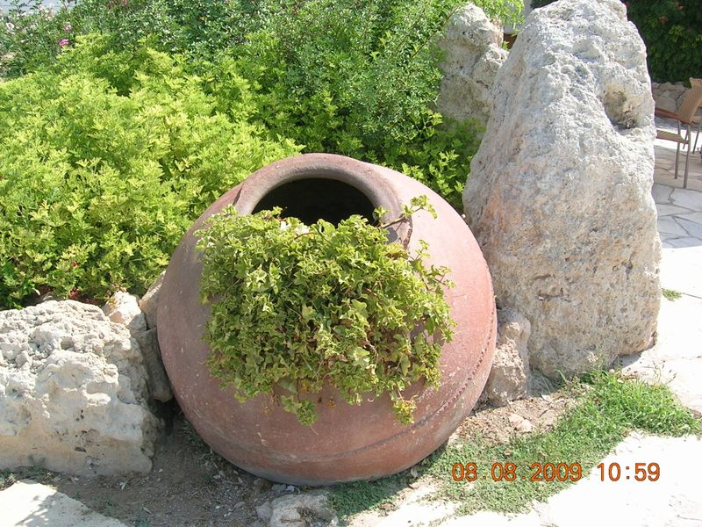](http://cordelia.typepad.com/.a/6a00d8345269c569e20120a6071029970c-pi)

**MODEL ANSWER**

Dear Editor,

I am writing to express my concern about our local council's suggestion to dig up Antalya Place in order to plant a flower garden for the elderly.

On the one hand, a flower garden will brighten up the area. Besides, flowers and plants provide a habitat for a wide variety of insect life. The garden would also provide a focal point for the elderly to meet each other. As for the trees, they are very welcome. They provide shade, reduce pollution and noise levels and offer protection against the wind.

On the other hand, young people need an opportunity to practise ball games.Most of them live in flats and there are no gardens nearby. Local football and netball teams have been winning matches for a long time now. If they cannot practise, they will certainly be less successful and , as a result, morale and team confidence will sink. In addition, young people meet friends,have picnics, watch matches and enjoy themselves here. Without this area, boredom and resentment might set in. I am also afraid vandalism might be a problem.

Therefore, I strongly feel that the council should look for another place to plant a garden for the elderly. How about the abandoned field on the outskirts of our town? I truly hope that the council will reconsider their decision as, I am sure, they wouldn't like to promote passive entertainment for the young.  (233 words)

Yours faithfully,

Bill Jones